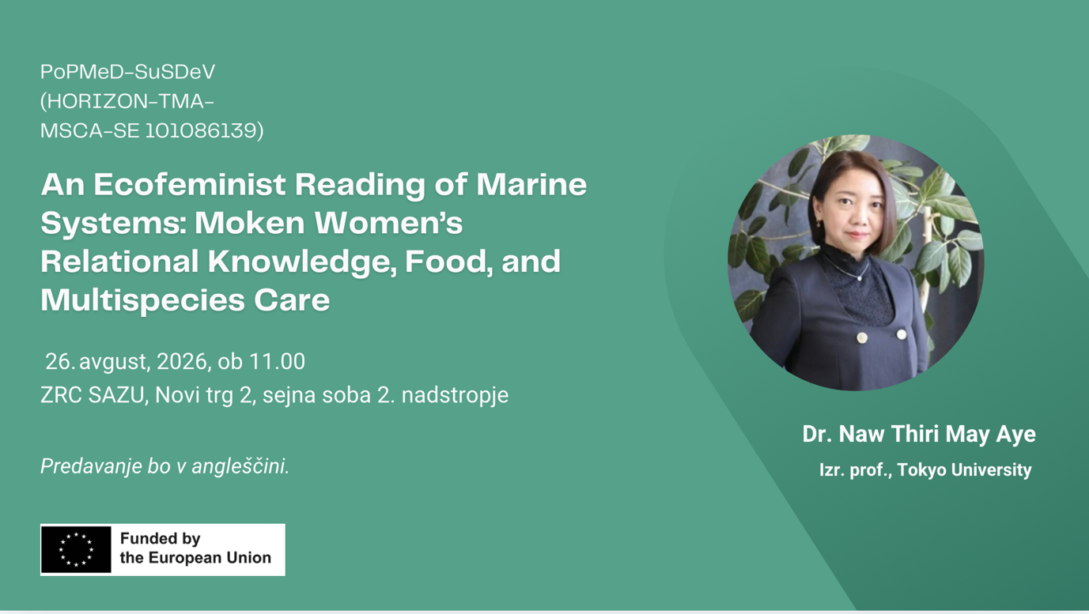
Izvleček v angleščini:
This study offers an ecofeminist reading of marine systems by centering the relational knowledge practices of Moken women in the Andaman Sea region who live across Thailand and Myanmar. The study draws on observations and interviews conducted as part of the author’s Blue Justice research project with Moken women across four island sites, including foraging, fishing, and food preparation in intertidal, nearshore, and tourism-affected coastal spaces. Moken women play a central role in sustaining households through food gathering, preparation, and redistribution. These practices enact multispecies care by regulating how, when, and what is gathered, maintaining ecological relations rather than maximising extraction. This knowledge is inseparable from relations of care that extend across human and non-human life, regulating how marine resources are accessed, shared, reused, and conserved. The use of “leftovers” from marine and tourist economies is examined as a critical site where unequal resource distribution, redirected bioenergy, and care-based survival intersect. It argues for more inclusive approaches to marine sustainability that recognise Indigenous women’s knowledge practices as essential to both ecological resilience and social justice.

Življenjepis (v angleščini):
Naw Thiri May Aye is an Assistant Professor at the University of Tokyo’s Graduate School of Frontier Sciences, where she focuses on political ecology and ecological economics, especially on natural disasters, displacement, environmental migration, and environmental justice. She holds two PhDs: a PhD in International Development from Nagoya University, Japan, and a PhD in Environmental Science and Technology from the Institut de Ciència i Tecnologia Ambientals (ICTA-UAB), Universitat Autònoma de Barcelona, Spain. Her PhD research at Nagoya University examined social vulnerability and environmental migration following the Great East Japan Earthquake and Tsunami. Her second PhD at ICTA-UAB focused on contested emissions and socio-ecological struggles at energy and extractive frontiers in Japan and Myanmar.

